Launch4j and Inno Setup Guide
Objective
This document explains how to generate a Windows executable (.exe) using Launch4j and package it into a Windows installer (.exe) using Inno Setup.

Prerequisites
Before you begin, ensure the following software is installed:
- Java JDK (Java 25 or your project version)
- Maven or Gradle (depending on your project)
- Launch4j
- Inno Setup Compiler
- Application JAR file
- Application icon (.ico)

Step 1: Build the Java Application
- Generate the executable JAR file. : mvn clean package
- The generated JAR will be available in: target/
- Example: activepulse-agent-1.0.0.jar

Step 2: Prepare the Application Folder
- Create a folder structure similar to:
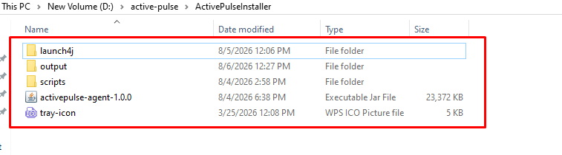

Step 3: Launch4j Configuration Steps
- Launch Launch4j and create a new configuration.
- Configure the Basic Tab
  - Output file
    - Click the Browse button.
    - Select the location where you want to generate the executable (.exe).
  - Jar
    - Click the Browse button.
    - Select your application JAR file.
  - Icon
    - (Optional) Select your application icon (.ico).
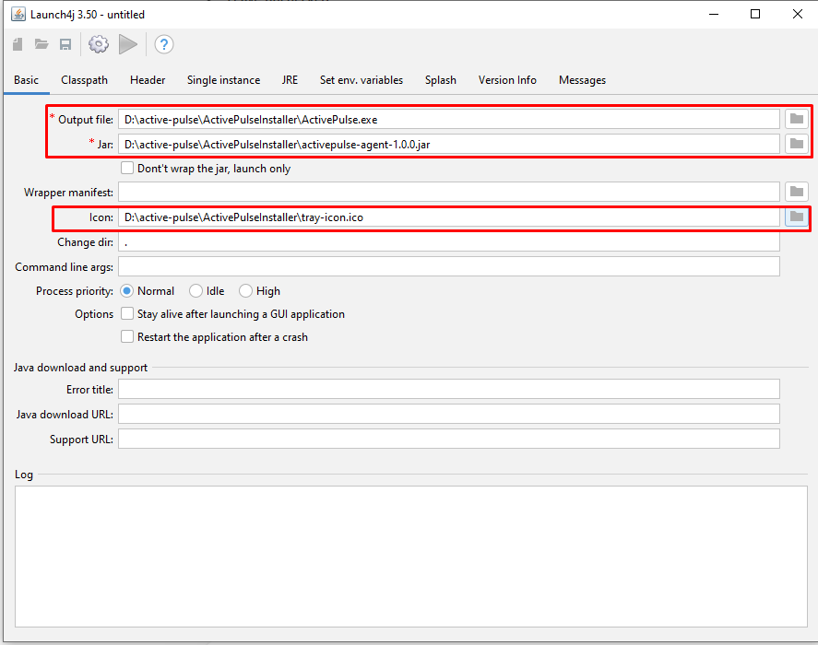
- Configure the JRE Tab
  - Min JRE version (Use your application's Java version.)
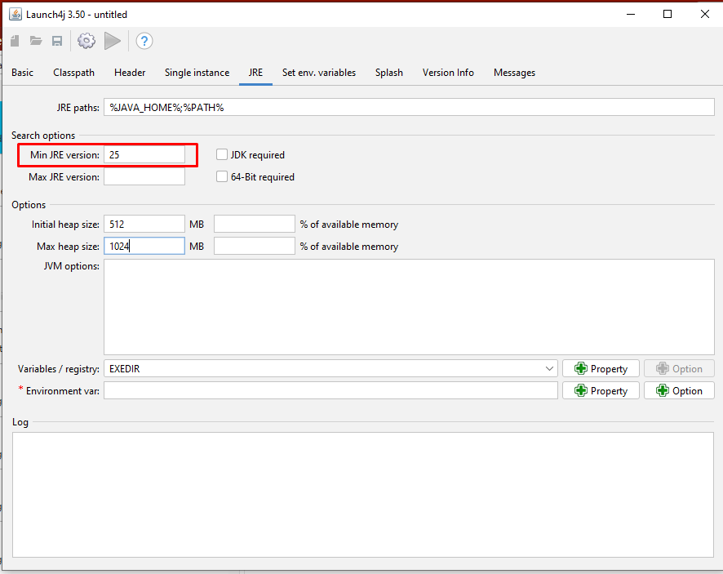
- Build the EXE
  - After completing the above configuration:
    - Click Build Wrapper.
    - Wait for the build to complete.
    - Verify that the executable file is generated at the specified output location.
    - Run the generated .exe file to ensure the application starts successfully.
- Important Note
  - Configure only the following tabs:
    - ✅ Basic
    - ✅ JRE
  - Do not modify any settings in the following tabs:
    - Classpath
    - Header
    - Single Instance
    - Set env. variables
    - Splash
    - Version Info
    - Messages
These tabs should remain with their default settings unless there is a specific project requirement.

Step 4: Inno setup Configuration Steps
- Open Inno Setup
  - Open Inno Setup Compiler.
  - The Inno Setup Script Wizard appears.
  - Leave Create a new empty script file unchecked.
  - Click Next.
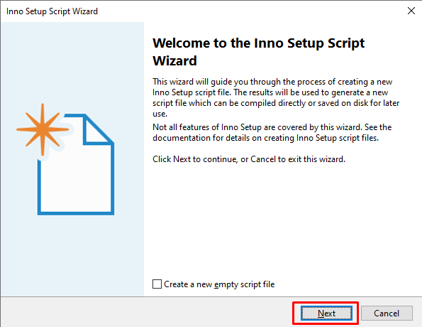
- Application Information
  - Enter your application details.
Field | Value
Application name | ActivePulse
Application version | 1.0.1
Application publisher | Your Company Name
Application website | Leave blank (or enter company website)
  - Click Next.
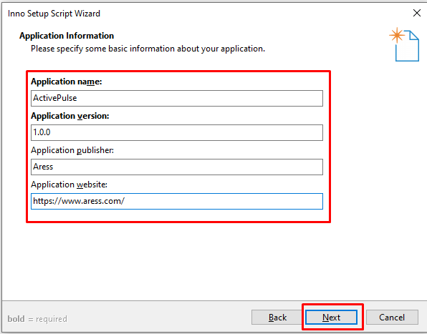
- Application Folder
  - Configure the installation folder.
    - Application destination base folder : Program Files folder
    - Application folder name : ActivePulse
    - Keep checked : Allow user to change the application folder
    - Do not select : The application doesn't need a folder
  - Click Next.
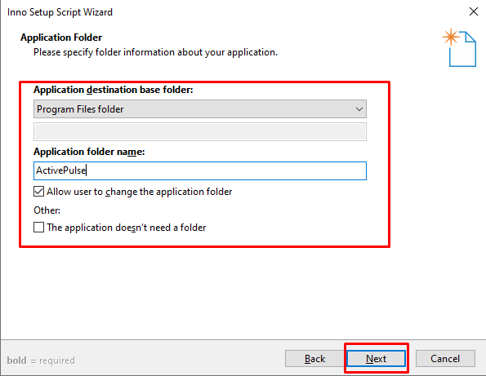
- Application Files
  - Application main executable file
    - Click Browse and select:ActivePulse.exe(Generated using Launch4j.)
    - Keep checked:Allow user to start the application after Setup has finished
  - Click Add Files... if required.
  - Click Next.
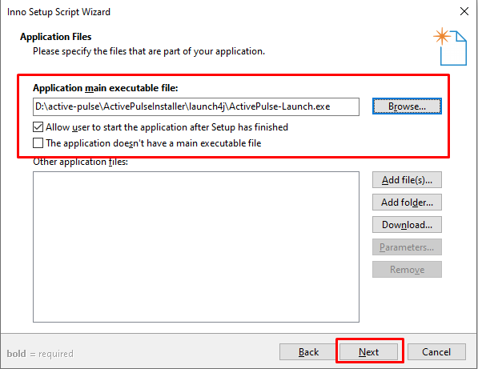
- Application File Association
  - Uncheck : Associate a file type to the main executable
  - Leave everything else blank.
  - Click Next.
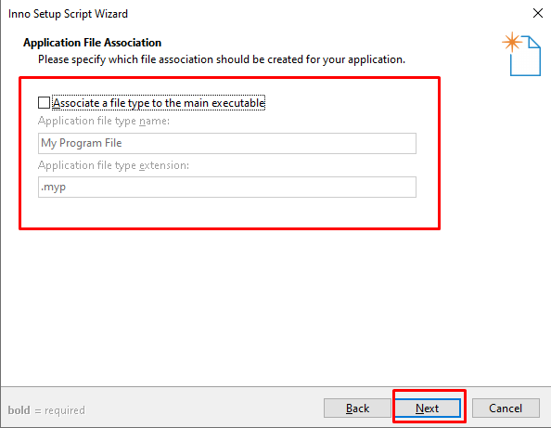
- Application Shortcuts
  - Keep checked:
    - Create a shortcut to the main executable in the Start Menu Programs folder
    - Allow user to create a desktop shortcut
  - Leave other options unchecked.
  - Click Next.
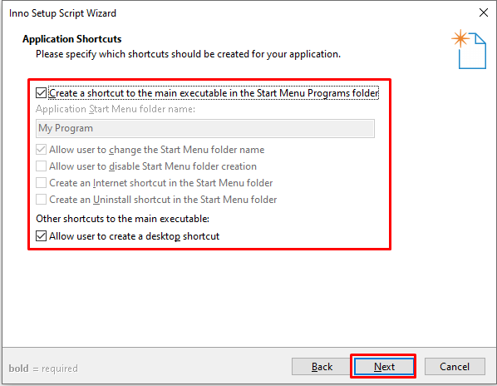
- Application Documentation
  - Leave all fields blank.
    - License file
    - Information file shown before installation
    - Information file shown after installation
  - Click Next.
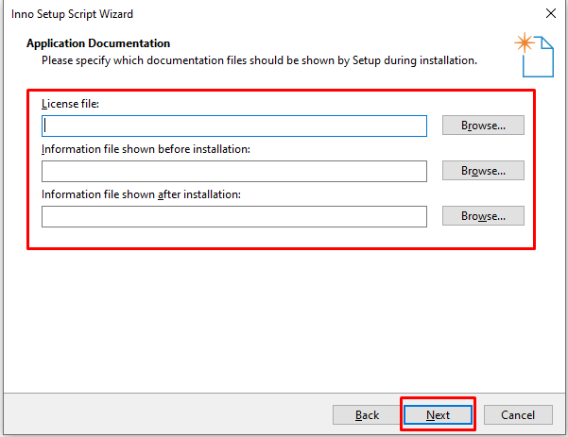
- Setup Install Mode
  - Select:Administrative install mode (install for all users)
  - Leave the remaining options unchecked.
  - Click Next.
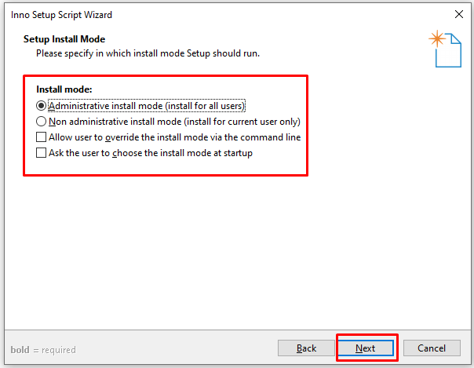
- Application Registry Keys and Values
  - Leave the registry file field blank.
  - Keep the default options:
    - Delete keys which are empty on uninstall
    - Delete values on uninstall
  - Leave all other options unchecked.
  - Click Next.
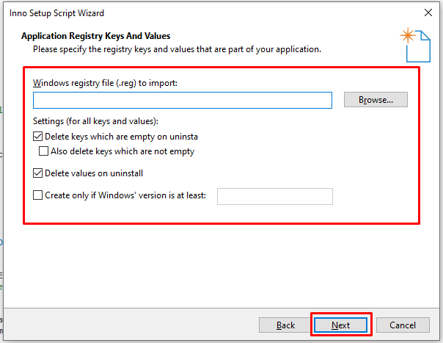
- Setup Languages
  - Select:English
  - Uncheck any other languages if selected.
  - Click Next.
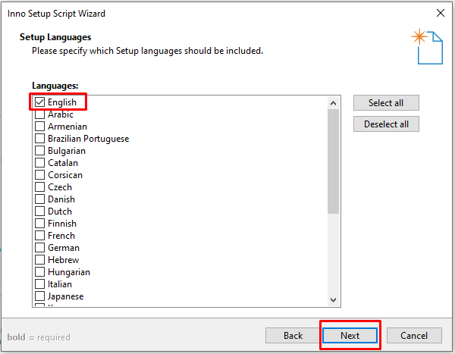
- Compiler Settings
  - Custom compiler output folder
    - Select the folder where the installer will be generated.
    - Example:D:\Release\Installer
  - Compiler output base file name
    - Example:ActivePulse-1.0.0
  - Custom Setup icon file
    - Browse and select : ActivePulse.ico
  - Setup password
    - Leave blank.
  - Click Next.
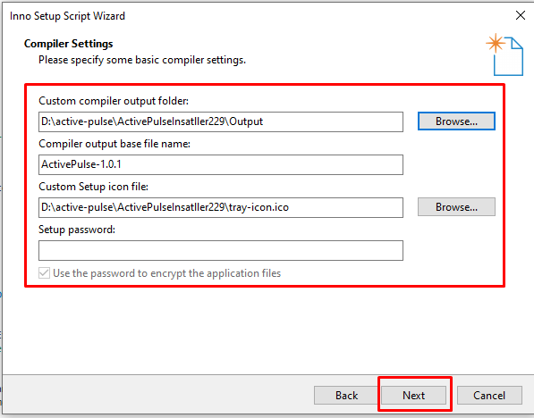
- Wizard Style
  - Keep the default values:
Setting | Value
Wizard style | Modern
Appearance | Dynamic
Theme | Default
  - Click Next.
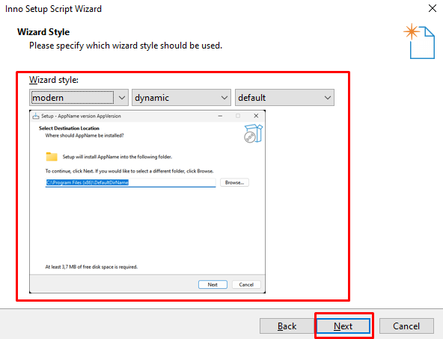
- Inno Setup Preprocessor
  - Keep checked:Yes, use #define compiler directives
  - Click Next.
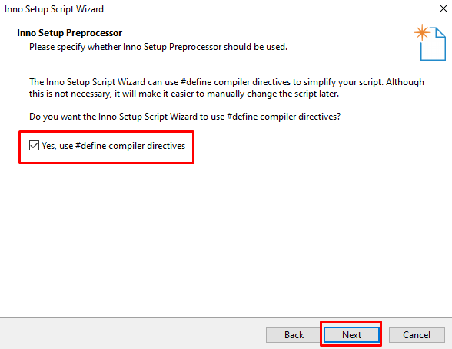
- Finish Wizard
  - Click Finish.
  - The wizard generates the .iss script.
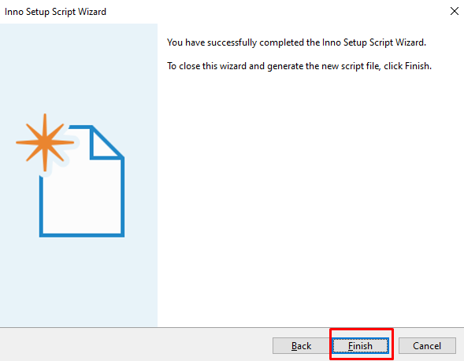
- Compile the Installer
  - In the Inno Setup Compiler, click:Build → Compile
  - or press:ctrl+f9
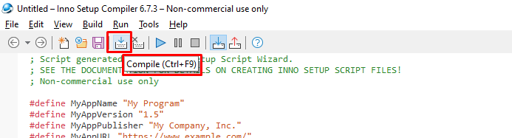
- Output
  - The installer will be created in the output folder you selected.
  - Example:D:\active-pulse\ActivePulseInsatller229\Output\ActivePulseSetup.exe
- Install and Test the Installer
  - Using Command Prompt
    - Open Command Prompt as Administrator.
    - Navigate to the downloaded ActivePulseAgent folder.
    - Run one of the following commands.
      - Silent Installation (Without Installation Logs) :
        - ActivePulseSetup.exe /VERYSILENT /SUPPRESSMSGBOXES /NORESTART
      - Silent Installation (With Installation Logs) :
        - mkdir logs
        - ActivePulseSetup.exe /VERYSILENT /SUPPRESSMSGBOXES /NORESTART /LOG="logs\ActivePulseInstall.log"
  - Using PowerShell
    - Open PowerShell as Administrator.
    - Navigate to the downloaded ActivePulseAgent folder.
    - Run one of the following commands.
      - Silent Installation (Without Installation Logs) :
        - .\ActivePulseSetup.exe /VERYSILENT /SUPPRESSMSGBOXES /NORESTART
      - Silent Installation (With Installation Logs) :
        - New-Item -ItemType Directory -Path .\logs -Force
        - .\ActivePulseSetup.exe /VERYSILENT /SUPPRESSMSGBOXES /NORESTART /LOG="logs\ActivePulseInstall.log"
  - Post-Installation Verification
    - Application is installed at:C:\Program Files (x86)\ActivePulse
    - Application logs are generated successfully.
    - Activity tracking is working as expected.
    - The ActivePulse agent is running in Task Manager.

Step 5: Deployment Guide – Upload Latest ActivePulse
- Objective
  - Deploy the latest ActivePulse installer to the download portal and update the download link so users can download the newest build.
- Login to CWP Control Panel
  - Open the following URL in your browser:https://44.221.252.71:2083
  - Enter your credentials and click Login.
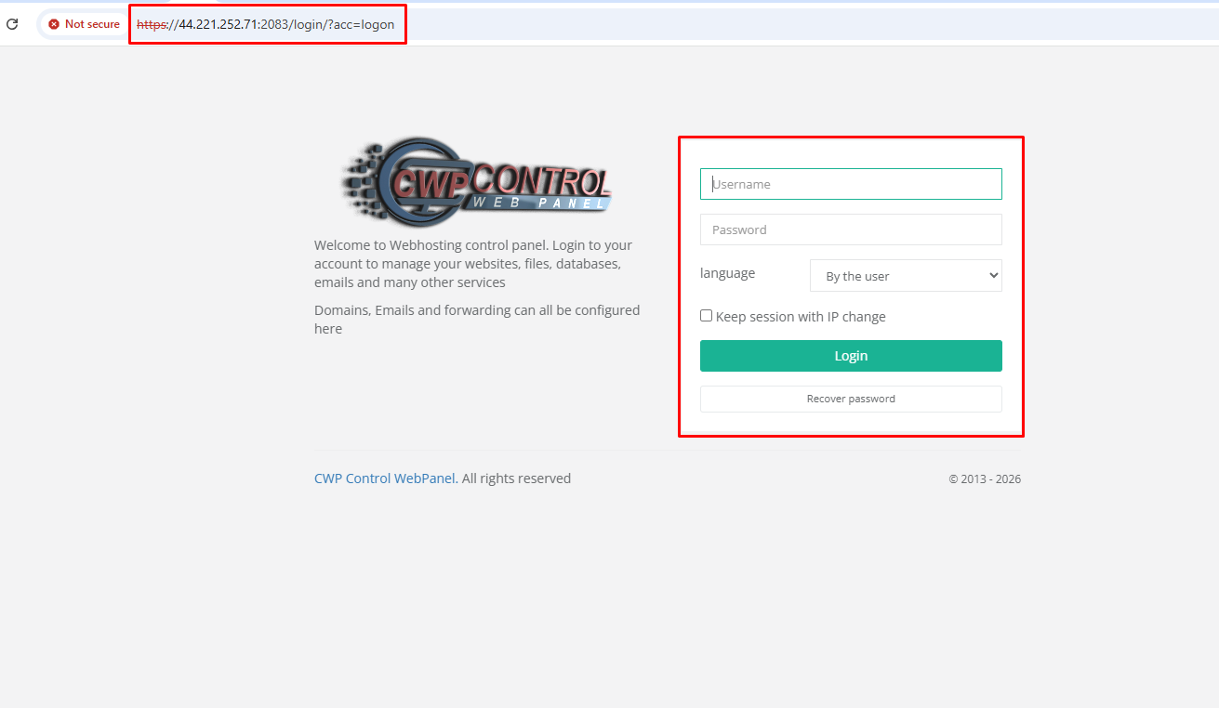
- Open File Manager
  - After logging in:
    - Click File Management from the left navigation menu.
    - Click File System Lock (if required).
    - Open File Manager.
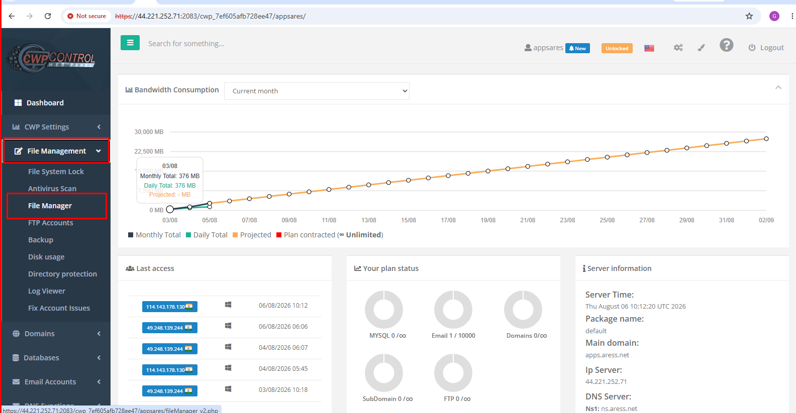
- Navigate to the ActivePulse Folder
  - In File Manager, navigate to:public_html ──> ActivePulse2.0
  - This folder contains:
    - ActivePulse installers (.exe, .msi, .dmg, .deb)
    - index.html
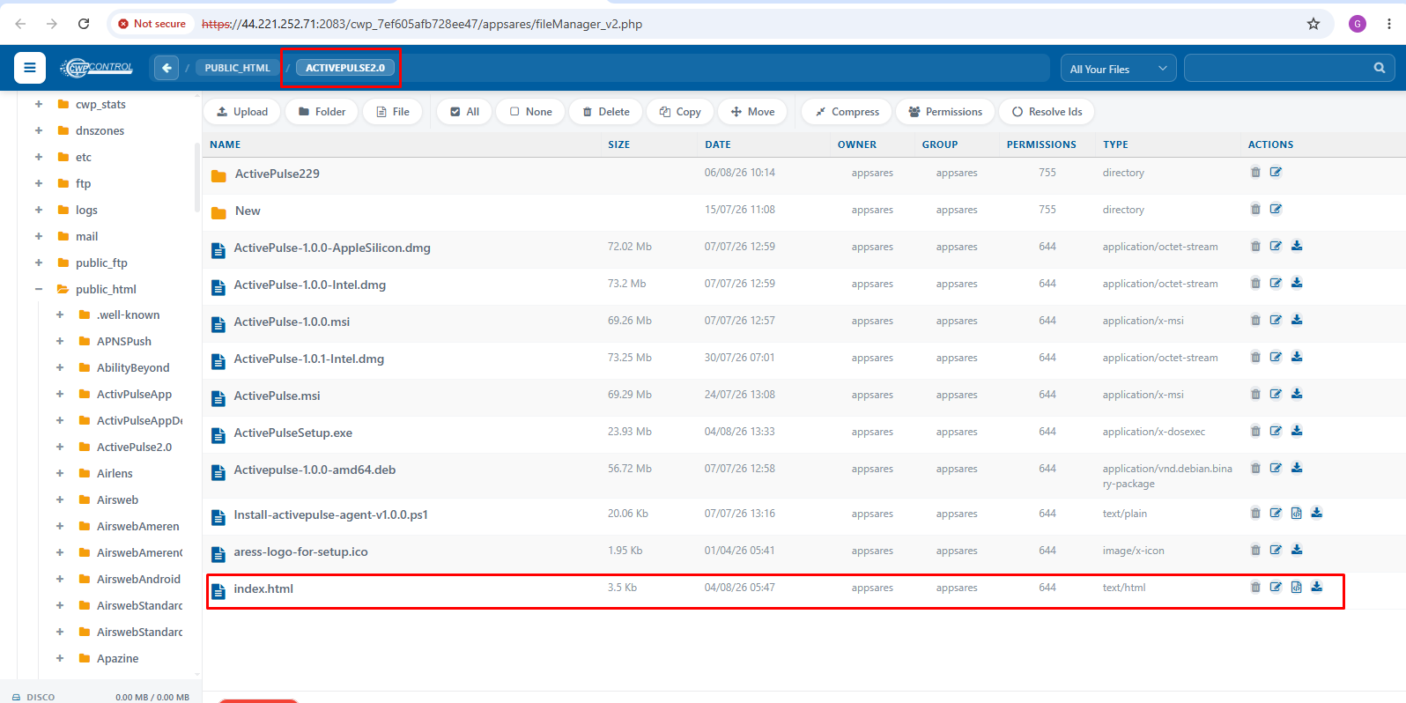
- Upload the Latest Build
  - Open the ActivePulse2.0 folder.
  - Click Upload.
  - Select the latest installer generated from Inno Setup.
  - Wait until the upload completes successfully.
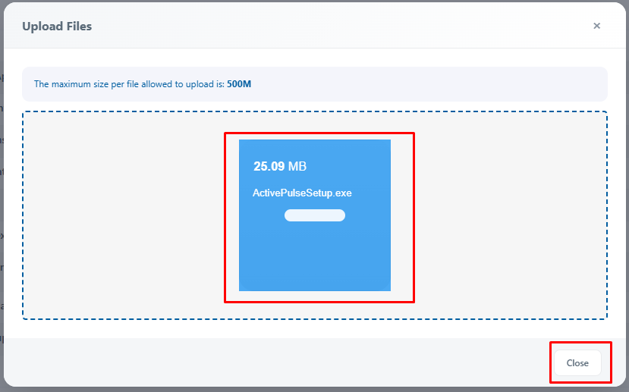
- Update the Download Link
  - After uploading the latest installer:
    - Locate index.html.
    - Click the Edit (pencil) icon.
    - Open the file in the editor.
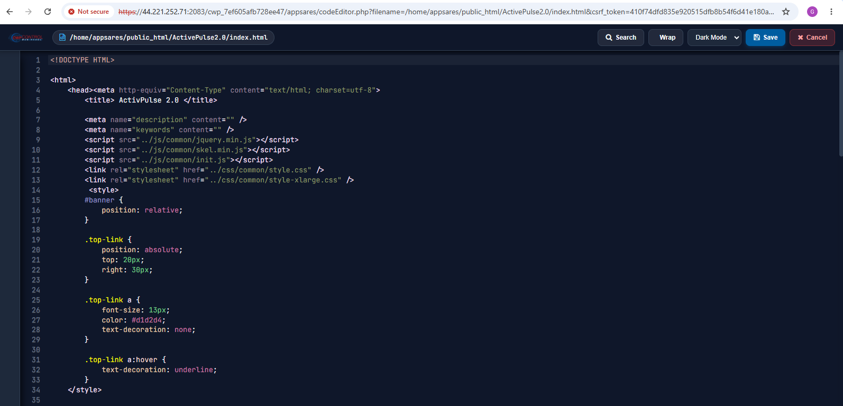
- Update the Installer Name
  - Find the existing installer filename.
  - Replace it with the latest uploaded filename.
  - Only update the filename.
  - Do not modify any other HTML code.
- Save the Changes
  - Click:Save
  - Wait until the file is saved successfully.
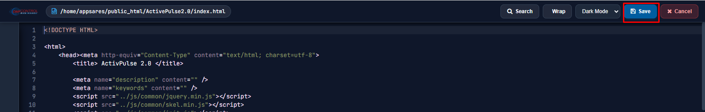
- Verify the Deployment
  - Open the download page in your browser:https://apps.aress.net/ActivePulse2.0/
  - Verify that:
    - The page loads successfully.
    - The Download button is visible.
    - Clicking the Download button downloads the latest installer.
    - The downloaded file matches the latest uploaded build.
